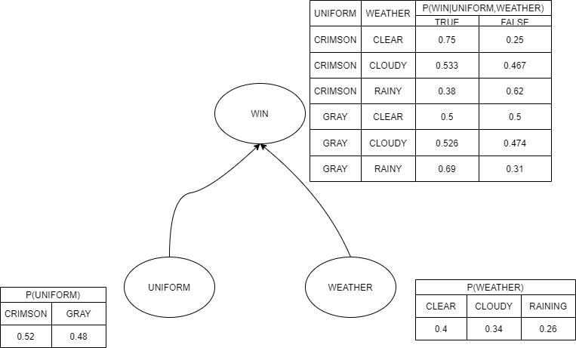

$$P\left(Uniform=Crimson,Weather=clear,Win=True,CallFriends=True,BuyJersey=True\right)$$

$$P\left(Uniform=Crimson\right)*P\left(Weather=Clear\right)**P\left(Win=True | Uniform=Crimson,Weather=Clear\right)*P\left(CallFriends=True|Win=True\right)*P\left(BuyJersey=True|Win=True\right)=$$

$$=0.6*0.3*0.9*0.7*0.6=0.06804$$

$$P\left(CallFriends=True | Uniform=Gray, Weather=Cloudy\right)$$

$$P\left(CallFriends=True | Win=True\right)*P\left(Win=True | Uniform=Gray,Weather=Cloudy\right)+P\left(CallFriends=True | Win=False\right)*P\left(Win=False | Uniform=Gray,Weather=Cloudy\right)=0.7*0.4+0.2*0.6=0.28+0.12=0.4$$

$$P\left(Uniform=Crimson | CallFriends=True,BuyJersey=True\right)=\frac{P(Uniform=Crimson, CallFriends=True,BuyJersey=True)}{P( CallFriends=True,BuyJersey=True)}=α*P\left(Uniform=Crimson, CallFriends=True,BuyJersey=True\right)=α*\sum_{Weather}{\sum_{Win}{P\left(Uniform=Crimson,Weather=clear,Win=True,CallFriends=True,BuyJersey=True\right)}}=α*\sum_{Weather}{\sum_{Win}{P\left(Uniform=Crimson\right)*P\left(Weather\right)*P\left(Win | Uniform,Weather\right)*P\left(CallFriends|Win\right)*P\left(BuyJersey|Win\right)}}=α*P\left(Uniform=Crimson\right)*\sum_{Weather}{P(Weather)\sum_{Win}{P\left(CallFriends | Win\right)*P\left(BuyJersey | Win\right)*P\left(Win | Uniform,Weather\right)=α*P\left(Uniform=Crimson\right)\left[P\left(Weather= Clear\right)*\left(P\left(CallFriends=True | Win=True\right)*P\left(BuyJersey=True | Win=True\right)*P\left(Win=True | Uniform=Crimson,Weather=Clear\right)+P\left(CallFriends=True | Win=False\right)*P\left(BuyJersey=True | Win=False\right)*P\left(Win=False | Uniform=Crimson,Weather=Clear\right)\right)+P\left(Weather= Cloudy\right)*\left(P\left(CallFriends=True | Win=True\right)*P\left(BuyJersey=True | Win=True\right)*P\left(Win=True | Uniform=Crimson,Weather=Cloudy\right)+P\left(CallFriends=True | Win=False\right)*P\left(BuyJersey=True | Win=False\right)*P\left(Win=False | Uniform=Crimson,Weather=Cloudy\right)\right)+P\left(Weather= Rainy\right)*(P\left(CallFriends=True | Win=True\right)*P\left(BuyJersey=True | Win=True\right)*P\left(Win=True | Uniform=Crimson,Weather=Rainy\right)+P\left(CallFriends=True | Win=False\right)*P\left(BuyJersey=True | Win=False\right)*P\left(Win=False | Uniform=Crimson,Weather=Rainy\right))\right]=}}$$

$$α*0.6*\left[0.3\left(0.7*0.6*0.9+0.2*0.3*0.1\right)+0.4*\left(0.7*0.6*0.6+0.2*0.2*0.4\right)+0.3\left(0.7*0.6*0.4+0.2*0.3*0.6\right)\right)=α*0.6\left(0.1152+0.1104+0.0612\right)=0.17208*α$$

In the same manner we calculate $P\left(Uniform=Gray | CallFriends=True,BuyJersey=True\right)$ to get the alpha value.

My computer is really lagging and I don’t really want to repeat the whole process again because it’s almost the same. We would just need to change Crimson to Gray.

In the end we will get $P\left(Uniform=Gray | CallFriends=True,BuyJersey=True\right)=0.08592*α$

$$α={(0.17208+0.08592)}^{-1}=3.876$$

$P\left(Uniform=Crimson | CallFriends=True,BuyJersey=True\right)$ =0.17208\*3.876=0.667.

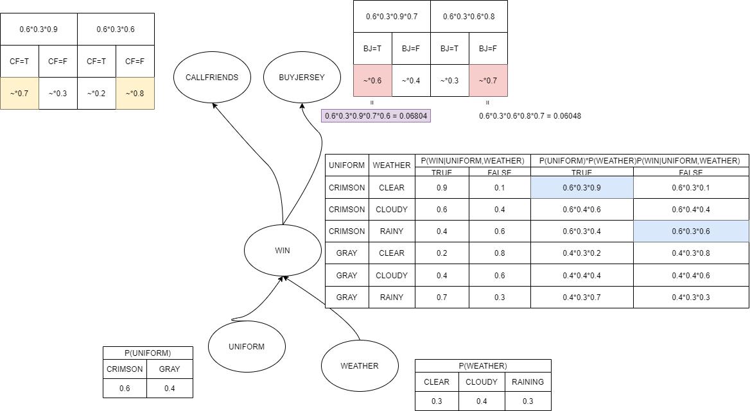

We start from Uniform and Weather. If we just pick the biggest values of those, we won’t be sure that the final answer is correct. That’s why we are making some kind of a multiplication but step by step. We compute the WIN table so that last two columns will show all possible multiplications by this step. We will choose the biggest value from both these columns because in the next two steps the final result will depend on Win or Lose. I colored them in blue. Next step is in yellow. We simply have to chose the biggest value for each combination to maximize the outcome. And the same for the last step. It’s in red. As a result we get two multiplications and it can be inferred that P(Uniform = Crimson, Weather = Clear, Win = True, CallFriends = True, BuyJersey = True) is the most possible sample because its probability is the highest and = 0.06804.

Yes, it is consistent because they both let us build a full joint probability distribution for Win. If they were dependent to each other, it would be impossible to get such distribution.